**Source 1 -- Influence of structure on mechanical properties of 3D printed objects**

* Researchers used a model Z310 3D printer.
* Tested 3 different types of hollowed-out structure
  + Honeycomb
  + Drills (circles)
  + Stripes (slanted rectangles)



* Tensile strength is calculated by taking the breaking force and dividing it by the minimum cross-sectional area.
* Honeycomb structure exhibited the highest strength

**Source 2 -- Optimization of fused deposition modeling parameters for improved PLA and ABS 3D printed structures (mostly all for tensile testing)**

* Varied conditions such as infill pattern, infill density, and infill speed.
* Tensile, bending, and compression testing were used for an in-depth analysis
* RESULTS
  + Young’s modulus increased as infill density increased
  + PLA parts with 100% infill density had the highest Young’s modulus of 1538.05 MPa
  + 90mm/s infill speed showed the highest Young’s modulus for PLA
  + The optimal temperature for PLA is 215 degrees Celsius
  + **Bottom Line**: 100% infill density, 90mm/s infill speed, 215 Celsius nozzle temperature, and linear infill pattern were most effective for maximizing the strength of parts.
* Scanning electron microscopy (SEM) revealed that the strength of the samples was dependent on the arrangement of their layers
  + This would lead us to believe that it is worthwhile to pursue the optimal infill pattern for 3D printed repairs
* Advantages of 3D printing -- could use for introduction/applications
  + Complex geometries as a single unit
  + Lower material and labor cost
  + Manufacturing advantages (CAD model -> print -> install)
* Material saved will only matter for mass production. PLA/ABS is very cheap, so would we be worried about a little extra material in exchange for greater strength? *Brainstorm applications with this*
* Increases in printing speed should be paired with increases in nozzle temperature
* Higher temperature = increased strength, but up to a certain point. If the temperature gets too high, it can lead to poor layer bonding, which can actually be detrimental to the printed parts’ overall mechanical strength. Therefore, it is important to note that the change in one parameter may have an effect on another parameter. For example, in our case, we are varying the infill pattern and infill density. If we vary the infill pattern, we may also alter the layer connections. This is something that we need to take into account
* Adding carbon fiber to ABS, so carbon-fiber-reinforced ABS filaments, significantly increased the tensile properties of the printed parts
* **Important:** magnitude of bending modulus of the five materials follows the same trend as the tensile modulus. Below is an image of the bending modulus of different materials

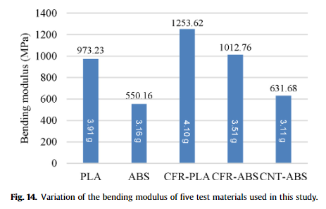

Challenges with 3D printing

* Knowledge gaps, lack of suitable materials, lack of expertise, part size limitations

**Source 3-- Study of infill print design on production cost-time of 3D printed ABS parts**

* The lowest infill density enabled cost savings, but mechanical properties decreased as infill density went down
  + Companies and real-world applications will have to do an independent analysis on this kind of thing
* Researchers analyzed various infill patterns combined with different mechanical properties (according to ASTM testing standards), and production cost-time

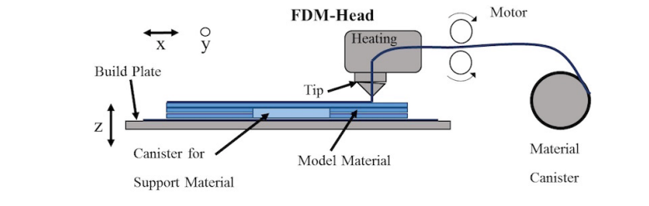

A good picture to describe the 3D printing process. Source, Bagsik and Schoppner (2011)

* Found that Honeycomb is really good
* The researchers found that for bending, low density had notable cost savings with a minimal loss in strength
* Time requirements are particularly important
  + How long does it take to print each sample?
  + When would this spec be important?
    - Touched on this already, no need to double back for it
* Choosing an optimal infill pattern can benefit mechanical properties, material cost and production
* Different software can be used to generate tool-paths for different infill patterns; in this project, we are using Slic3r
  + Not relevant
* Specimens that they studied were based on ASTM standards
  + Ours are as well
* They tested compression, testing, and bending
  + We focused on bending
* They determined cost per sample
* Production cost is defined as print cost $×$ print time
* Cost is calculated by finding the cost per minute of printing and then find
* The researchers tested a low density infill, high density infill, double dense infill, and solid infill
* Researchers found that higher reduction in cost means greater cost savings and higher reduction in mechanical strength
* Concluded that print cost had more of an impact on production cost than material cost (when using PLA)
* For bending applications, low density had good cost savings with minimal loss in strength
* Source suggests additional analysis on ‘custom’ infill patterns is required
  + Thats where we come in
* Good first step, but didn’t test specific infill patterns that we were interested in. We should do our own production-cost analysis to determine these specs for ourselves.

**Source 4 -- Observing the Effects of Infill shapes on the tensile characteristics of 3D printed plastic parts**

* Analyzed strength of four different infill patterns
  + Rectilinear, diamond, honeycomb/hexagonal, solid
* Samples had an infill density of 15%
* The hexagonal pattern gave the highest strength, and the solid pattern at 100% infill density had the weakest properties. The 100% solid behaved like a brittle material (Our data backs this up)
* Used ASTM standards

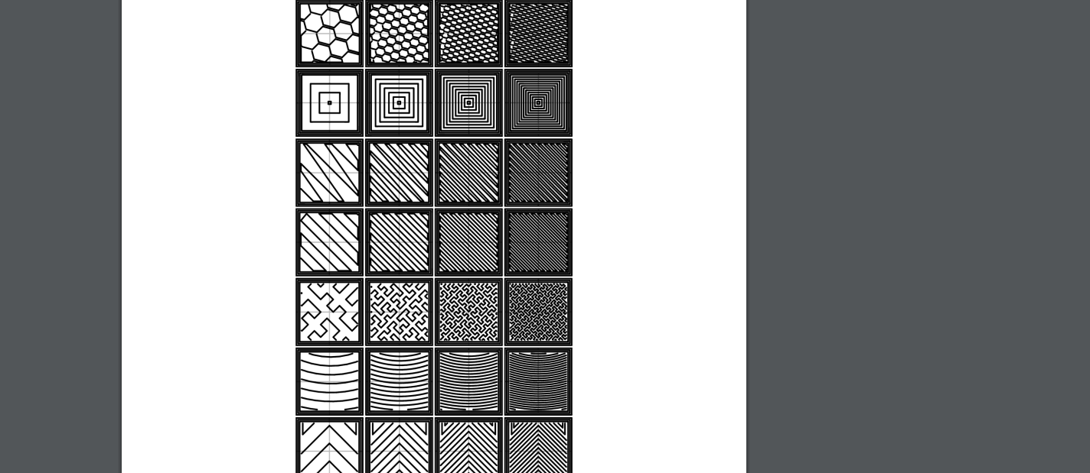

Is there a way we can make something like this for our team?

**Source 5 -- Zip-o-mat Slicer Ahlers et al**

“Slic3r – open source 3D printing toolbox,” 2018. [Online]. Available: <https://slic3r.org/>

* Describe the challenges of nonplanar toolpath generation and printing
* Describe Ahlers et al. solution to said challenges

**Source 6 -- Short review of nonplanar fused deposition modeling printing**

* Simpler explanation of Zip-o-mat
* Good picture of what Zip-o-mat does
* 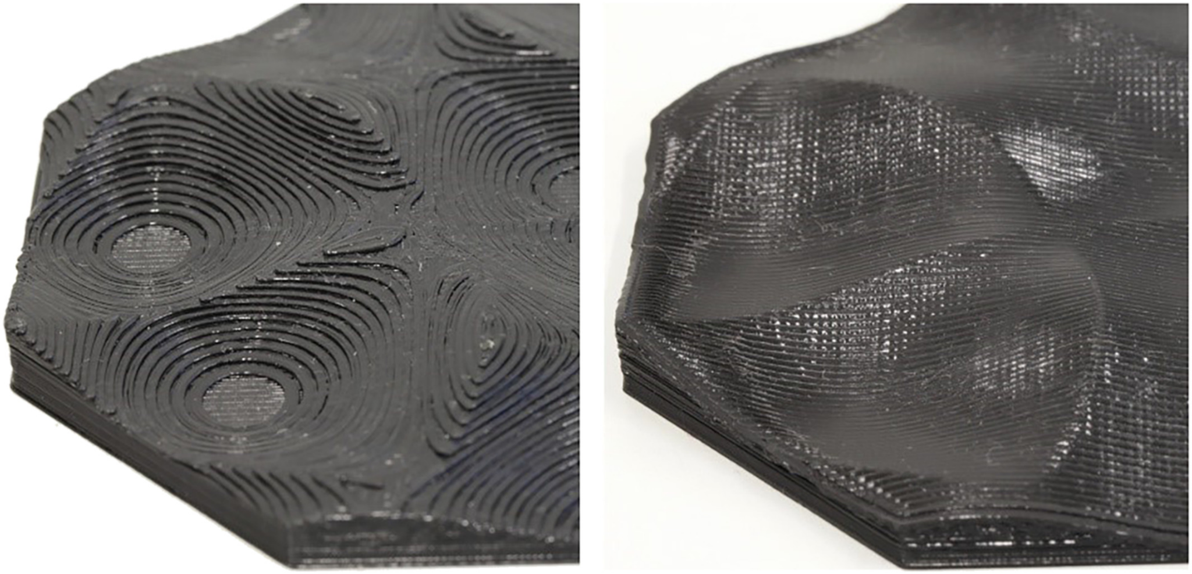

**Source 7 -- Saab 3D printed jet parts**

* Saab AB, a swedish aerospace company, tested a 3D printed repair in March 2021. A piece of the exterior structure of a Gripen aircraft was created using a 3D printer that took nylon polymer PA2200 [7].
* The company wanted to test how additive manufacturing could be applied in to a damaged component of machinery in a real-life battlefield setting.
* Applications include rapid repairs for jet aircraft that may have sustained damage during mission operations in remote locations
  + Could save time on turnaround
* There was no 3D model of the aircraft piece; it had to be scanned. This is similar to in-situ printing, because in real life, you won’t know what the damage is. It could be differente very time
* The results of the test were positive. No visible structural effects were seen.
* Has positive implications for the field
* Factors they took into account: flexibility, temperature at altitude, etc. Looking into better materials
* Nylon requires a higher printing temperature than PLA (around 250 C), however, it is

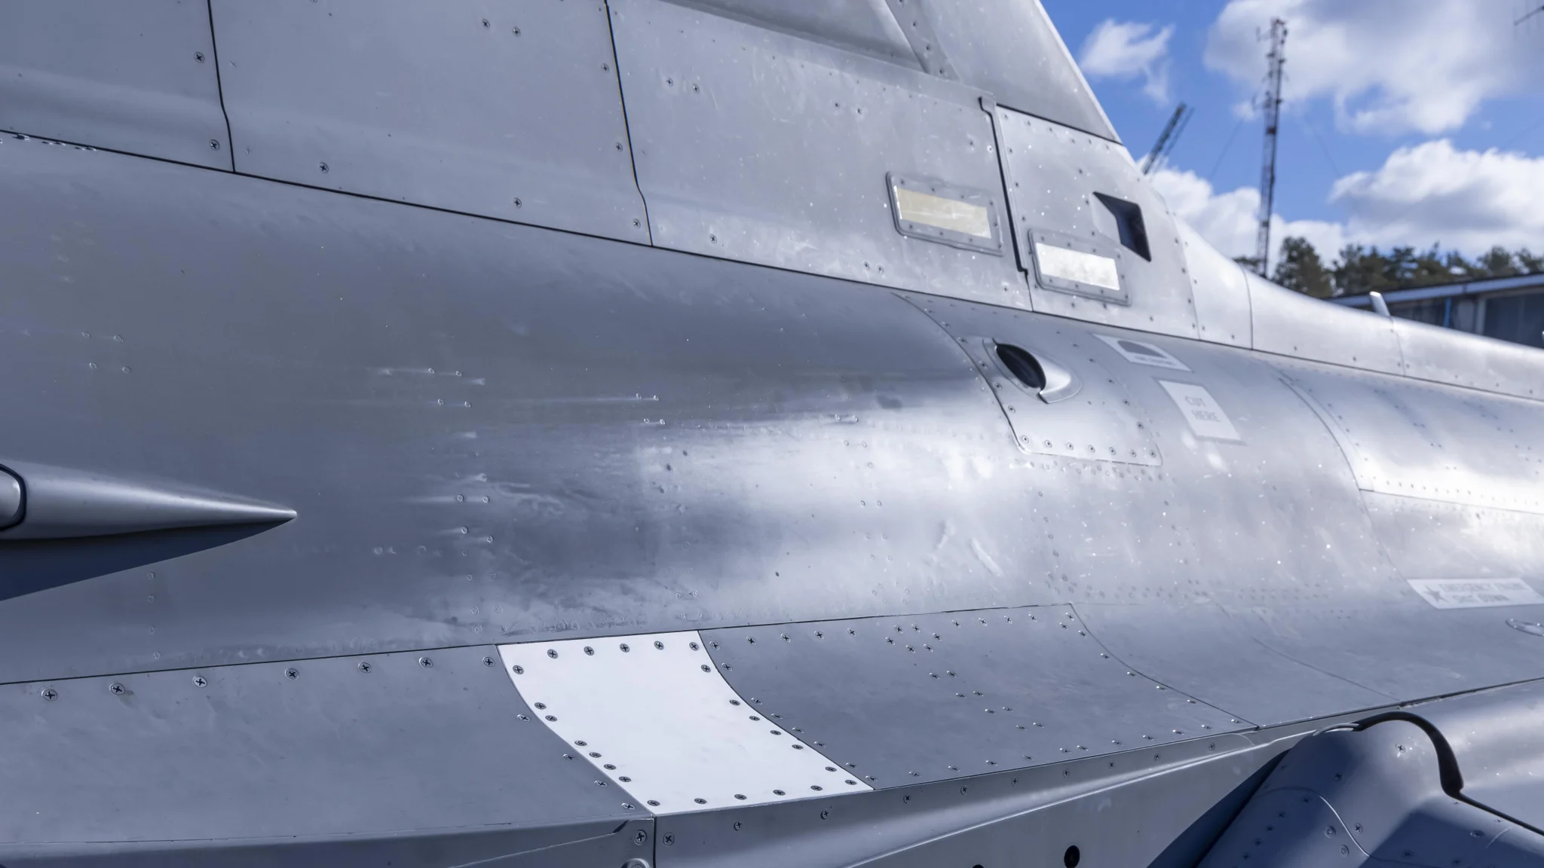

**Source 8 -- PLA (MIT source)**

* PLA is one of the world’s most researched 3D printed materials. It has proven applications in bio-printing, rapid manufacturing, construction and home development, and many more.
* Although PLA has a relatively high tensile strength and elastic modulus when compared to similar filaments, it is a very brittle material.
  + This means it would do poorly in applications that require plastic deformation at high stress levels
* The glass transition temperature is a crucial metric that affects density and heat capacity.
  + This is because noticeable changes in polymer chain mobility take place above Tg
* Physical properties are important and they are well documented. Will provide a quick summary of important properties that we care about in this project
  + Density: 1250 kg/m3
  + Melting temperature: 165 Celsius
  + Tensile Strength: 59 MPa
  + Elastic Modulus: 3500 MPa
  + Youngs Modulus: 1280 MPa

**Source 8** [**https://www.unipipes.com/blog/abs-plastic**](https://www.unipipes.com/blog/abs-plastic)

* Physical properties are important and they are also well documented
  + Tensile strength: 46 MPa
  + Density:
  + Melting temperature
  + Elastic modulus
  + Youngs modulus
* Resistant to chemicals, heat, and physical impacts
* Applications in the automotive industry
  + Seat backs
  + Seat belt parts
  + Handles
  + Trim
* Strong impact resistance make it ideal for applications that require structure and sturdiness

Source 9

<https://omnexus.specialchem.com/selection-guide/acrylonitrile-butadiene-styrene-abs-plastic>

* ABS requires a higher nozzle and bed temperature than PLA
  + ABS requires 80-110 Celsius while PLA requires 60-70 Celsius
  + ABS requires 210-250 Celsius nozzle temp while PLA requires 180-230 Celsius
* ABS tends to be less brittle than PLA
* ABS is the better choice for applications with large physical stress and extreme temperature ranges
  + However, it is also more challenging to print with
    - Tradeoff

Source 10

<https://omnexus.specialchem.com/polymer-properties/properties/elongation-at-break>

Source 11

<https://www.sciencedirect.com/science/article/pii/S0169409X16302058?casa_token=uTIEWwlQ_VMAAAAA:4XrEgm0KVI_-pz5tjLsQaDAqAxS_rEHyZbQWM6Z-DqxNJ_Y0DGs4y9Y68lwLOvLJYcG-Zo1VSA>